Advanced Graphics report

# dungeon scene

We have been tasked to create a dungeon scene using GLSL and AMD rendermonkey. We were provided with a list of effects to be implemented.

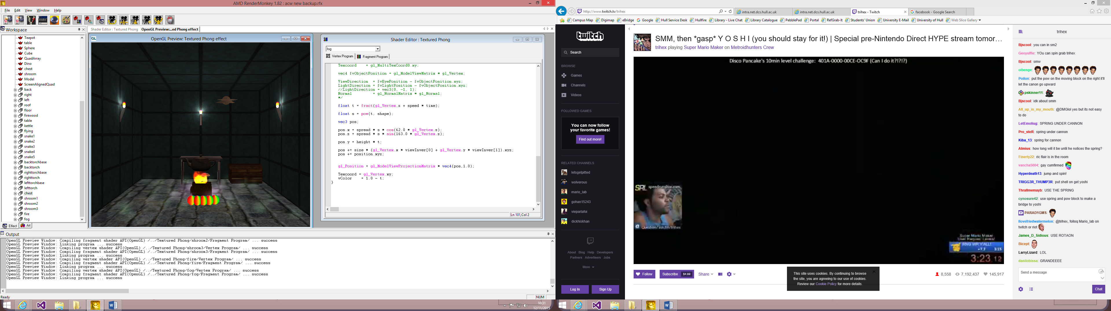

A view of the finished scene.

Basic effects

1. All walls apart from the floor are standardly textured with per vertex lighting.
2. The floor has been done using height mapping and per vertex lighting but has been dimmed to fit in with the scene.

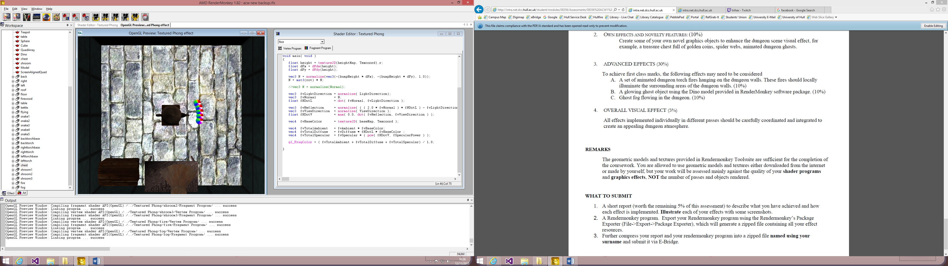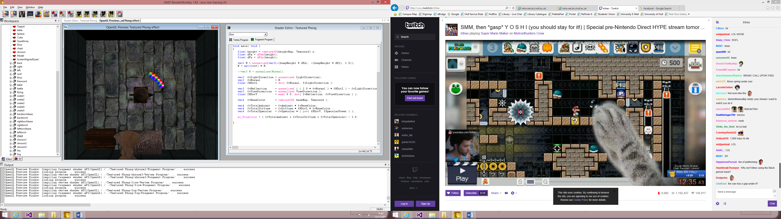

A top view showing the height mapped floor at full brightness and dimmed to fit scene.

1. The table has been rendered using per fragment lighting.
2. The fire in the center of the room has been done by merging 3 textures and using texture based animation.
3. The metal teapot above the fire has been rendered using the normal mapping technique to achieve a rusty and bumpy look.

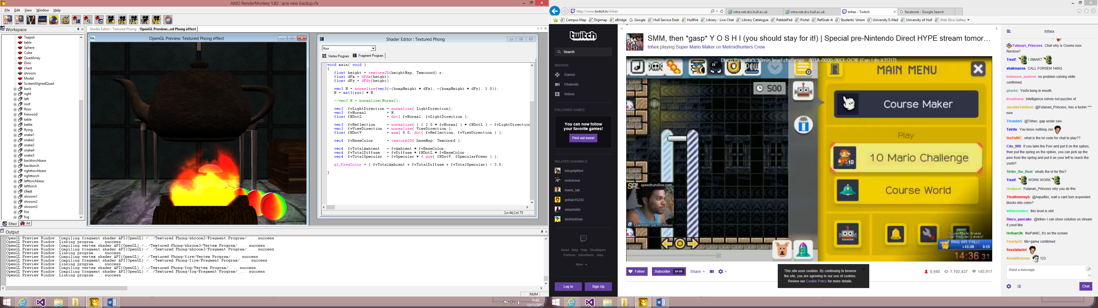

A view of the fire and rusty teapot.

1. The snake object on the floor is made using a series of spheres that rotate around the center of the scene using the time but each sphere after the first is delayed more than the last so they follow each other.
2. There is a flying sphere that uses a local deformation to create a pair of wings on each side and flaps the wings in accordance with time. The circular movement is done the same as the snake.

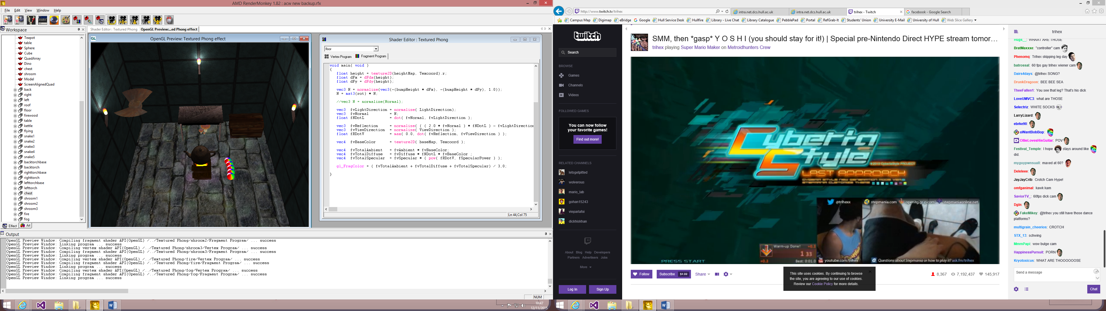

A view of both the rainbow snake on the floor and the flying sphere.

Own effects

For my own effects I have added a chest to the corner of the room and I have added 3 mushrooms to under the table.

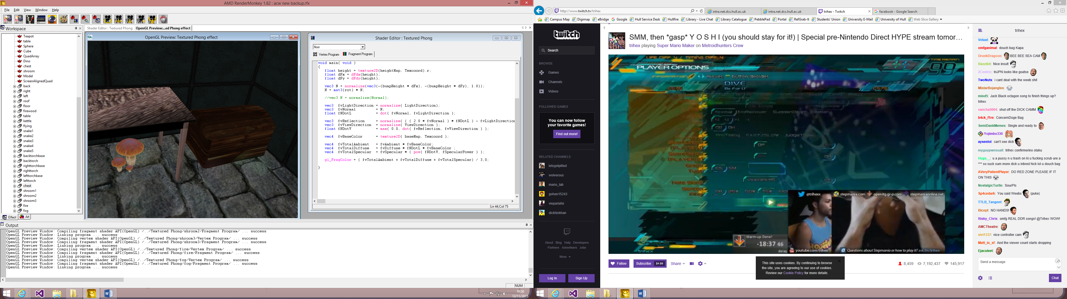

A view of the chest and mushrooms.

Advanced effects

I have added torches to the wall which use a particle system to create the fire and have local light programmed into the walls shaders to light the walls around each. I have also used the same particle system but with a different texture, no y movement and a much greater spread.

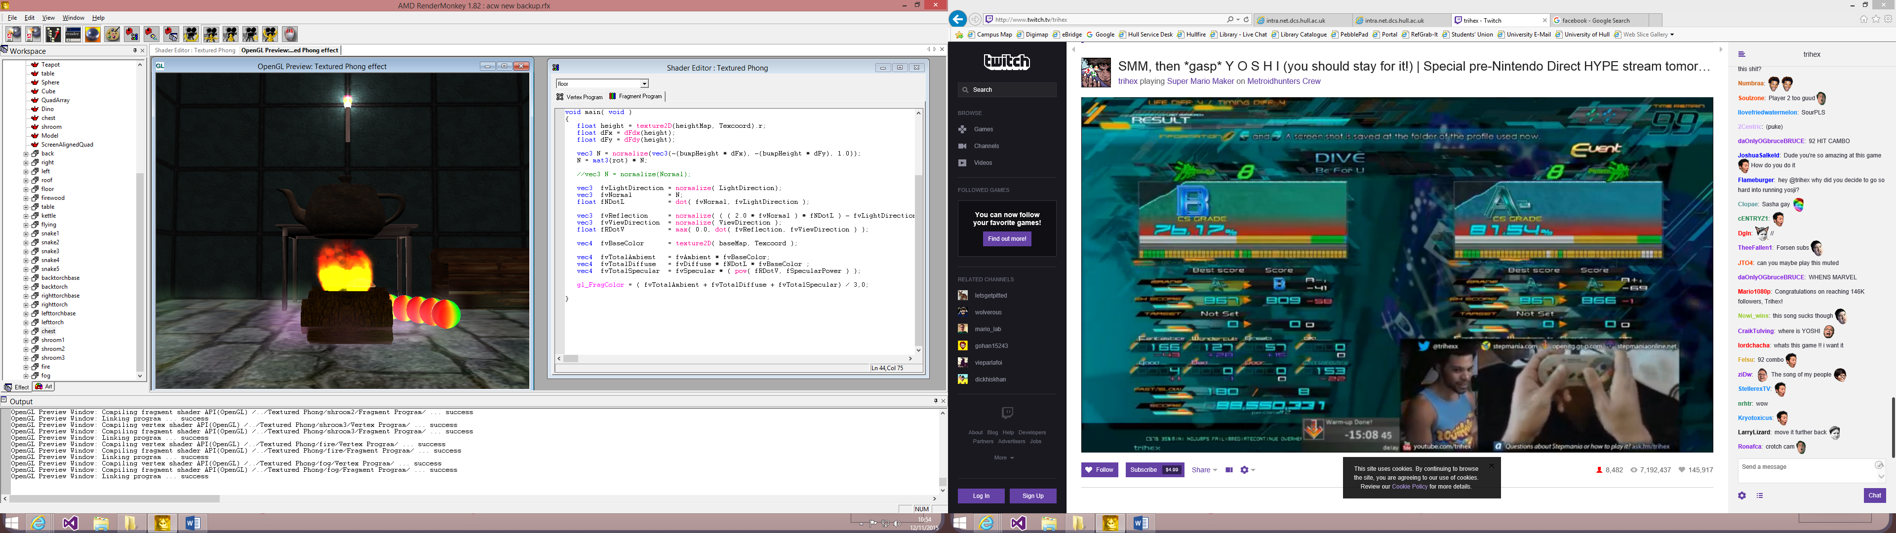

A view of the fog and local light torch.

Overall visual effect

I have dimmed the lighting on most things to try and make them all fit together in the scene I also made sure to pick models that would be seen in a dungeon eg. Chest and mushrooms not flowers and cakes.